Django resful API

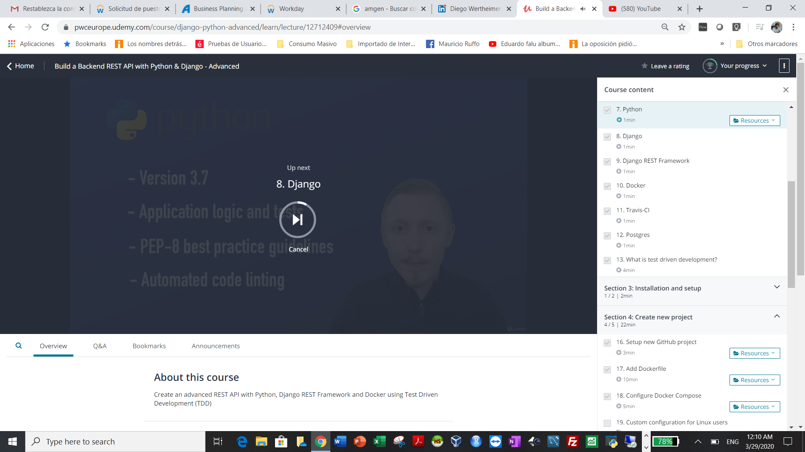\

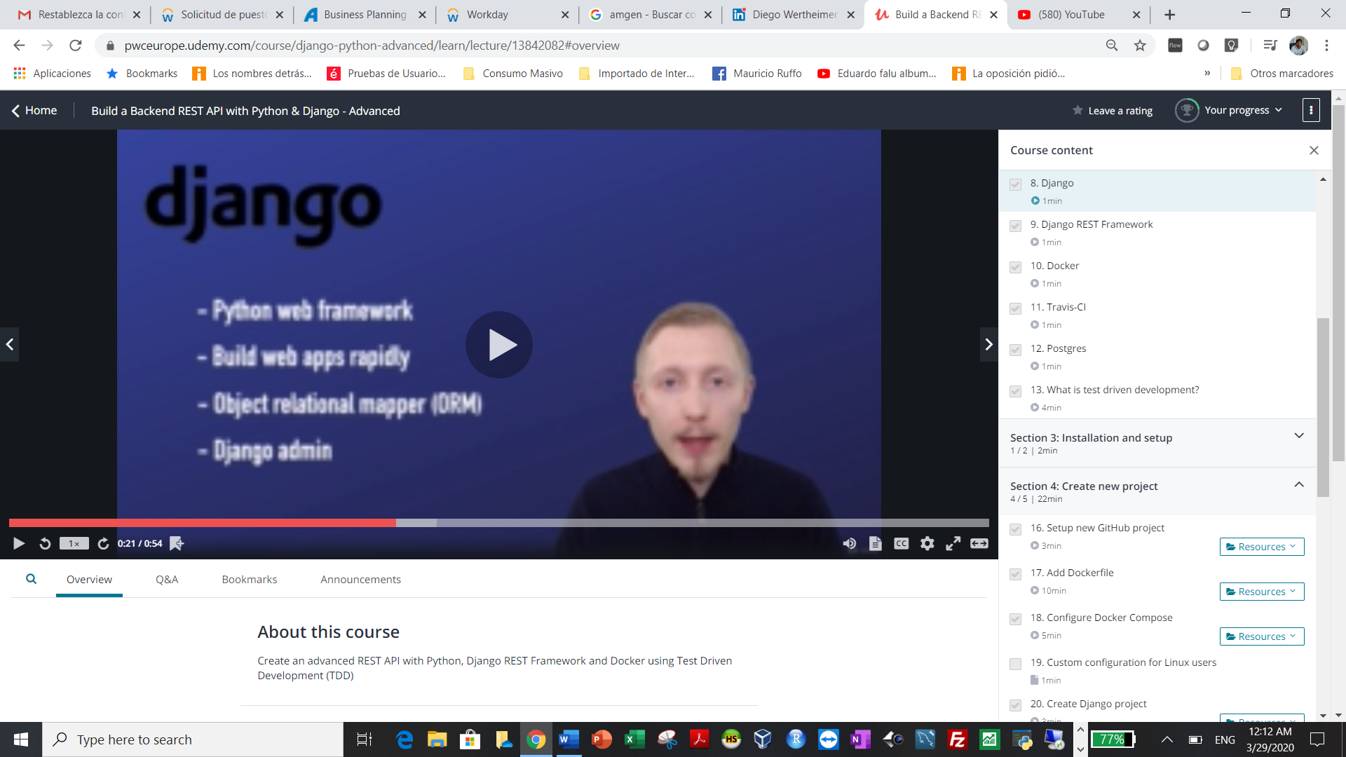

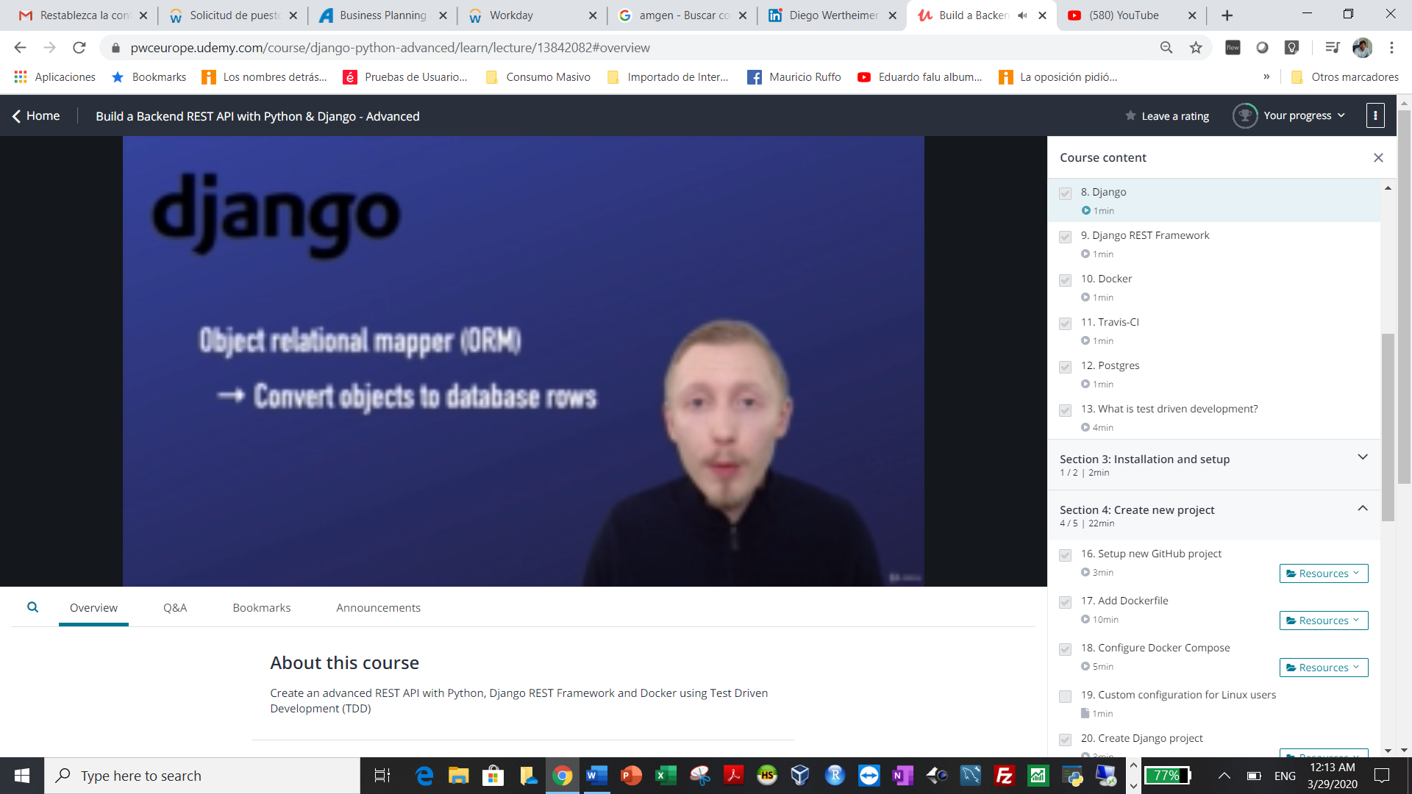

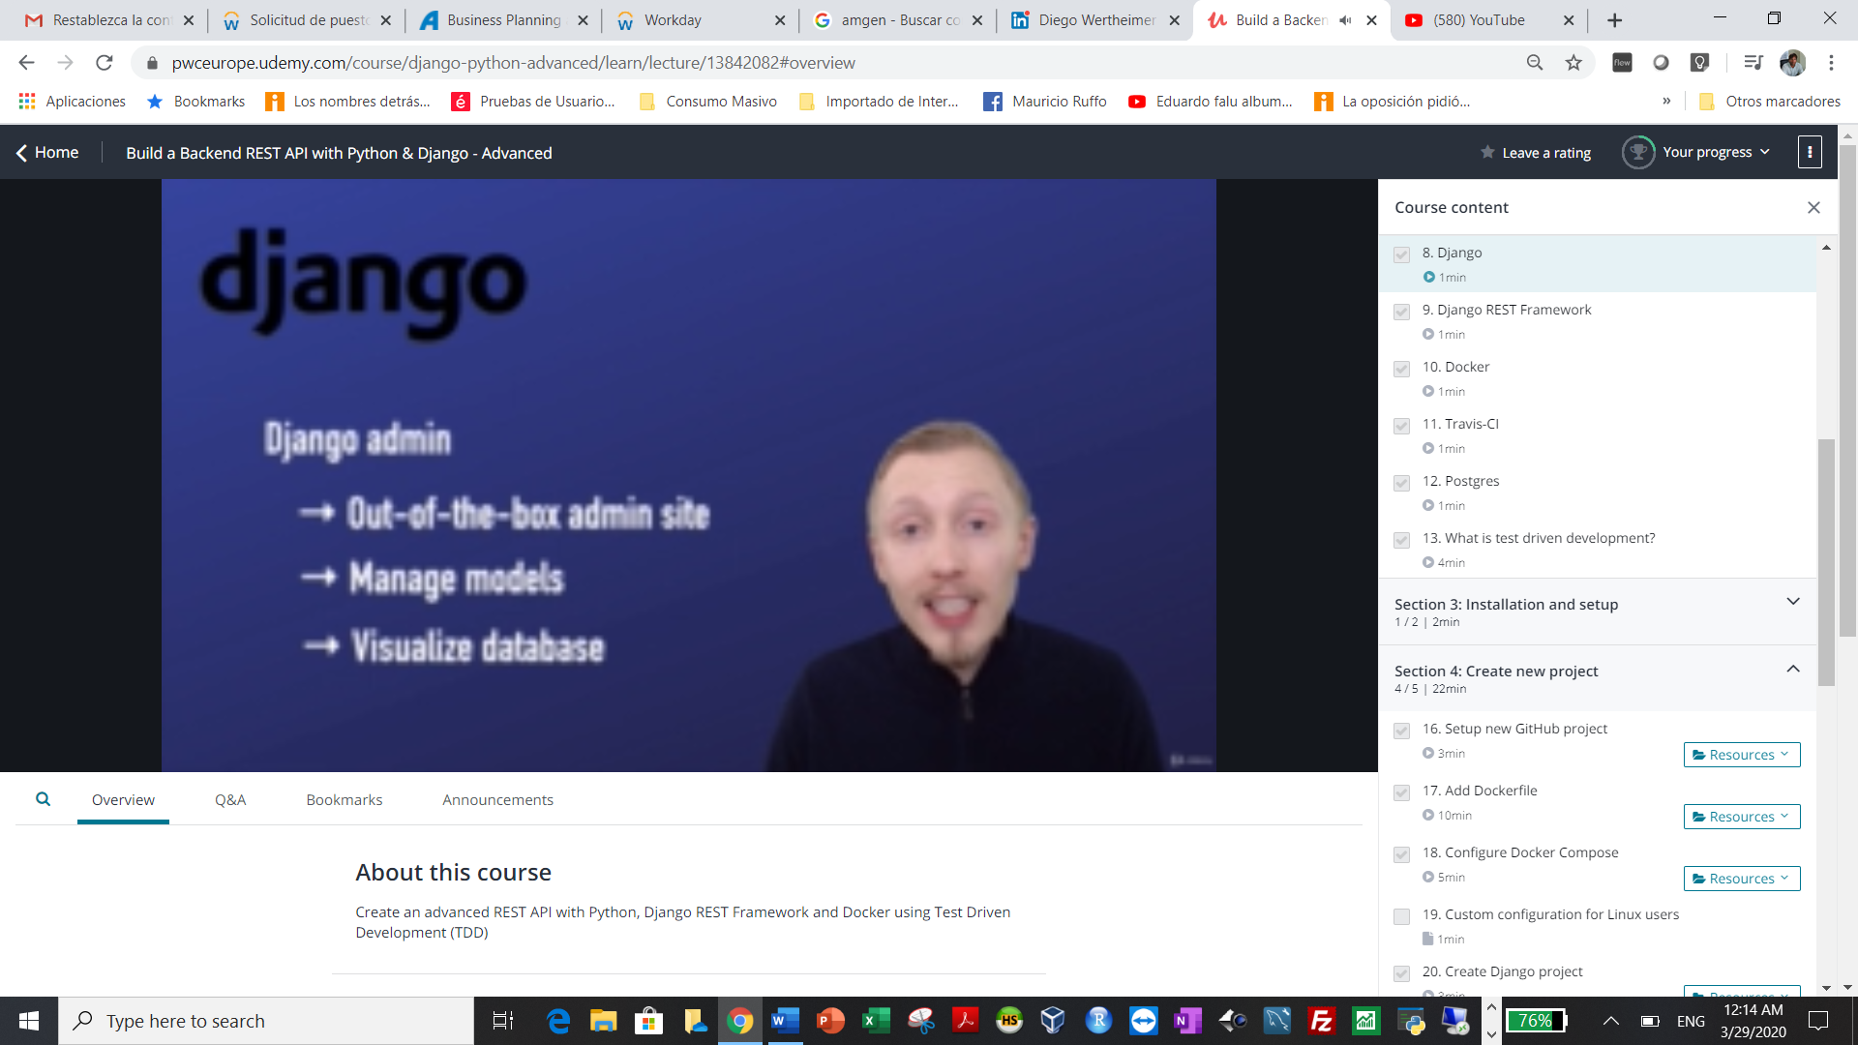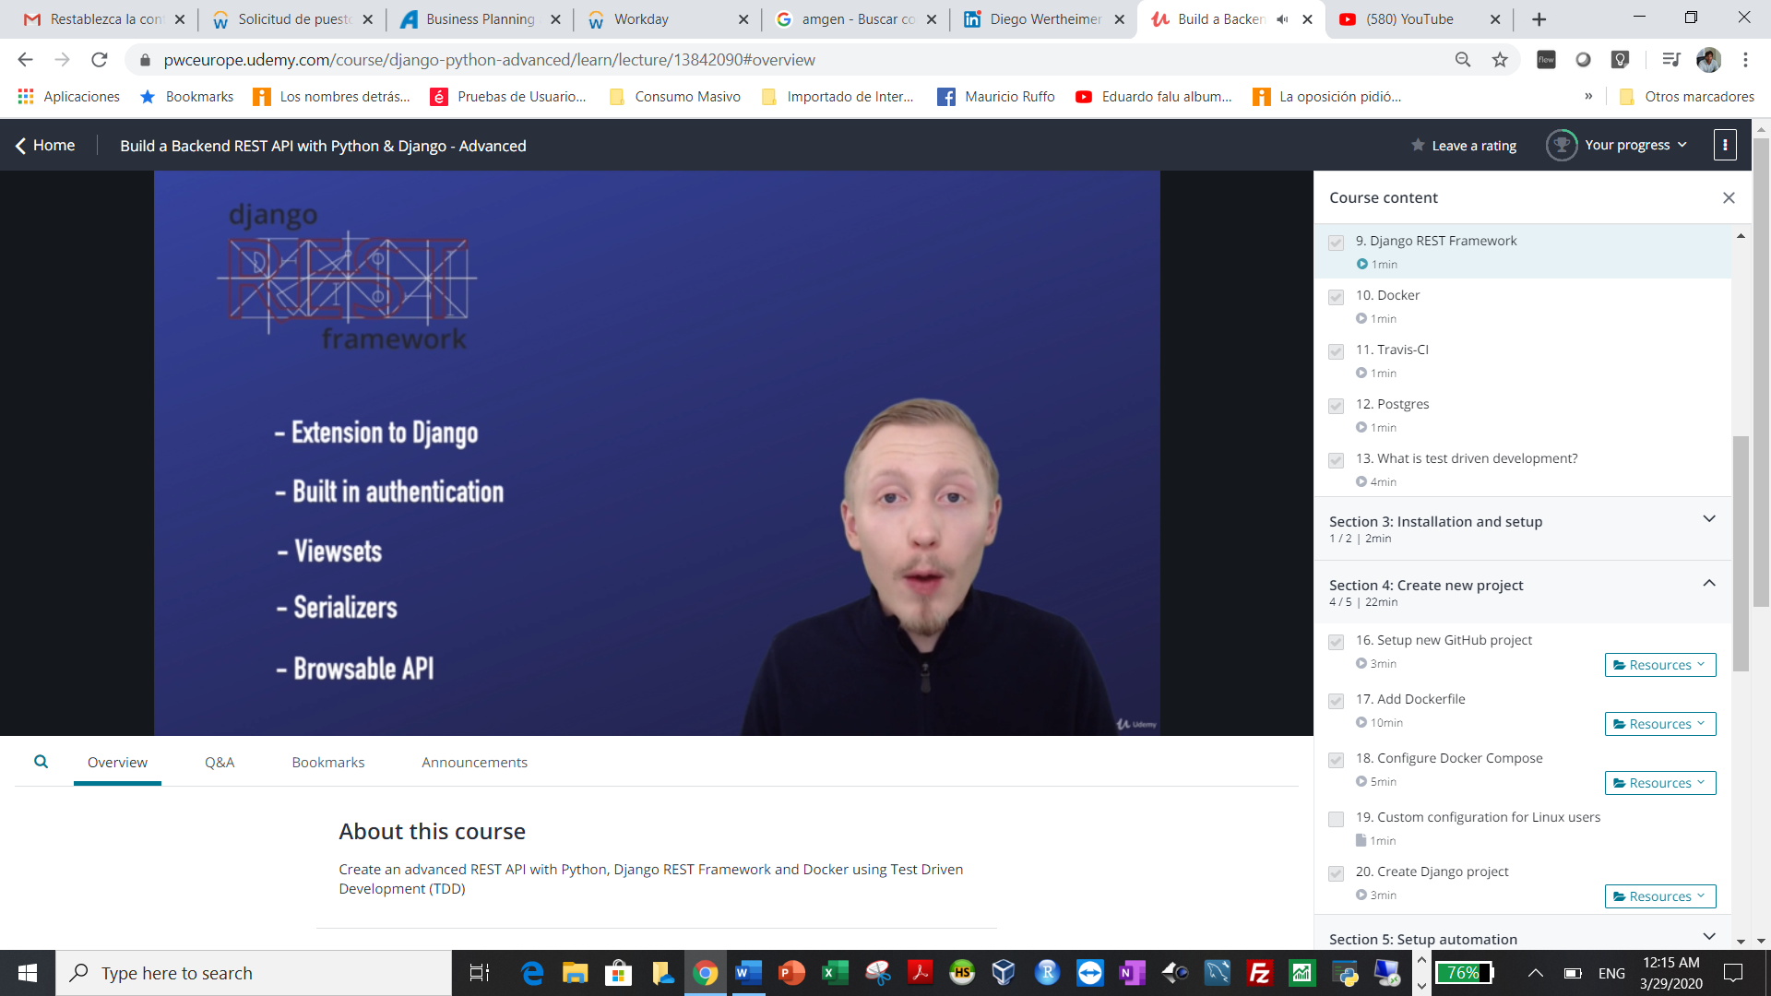

Dcker virtualization tool

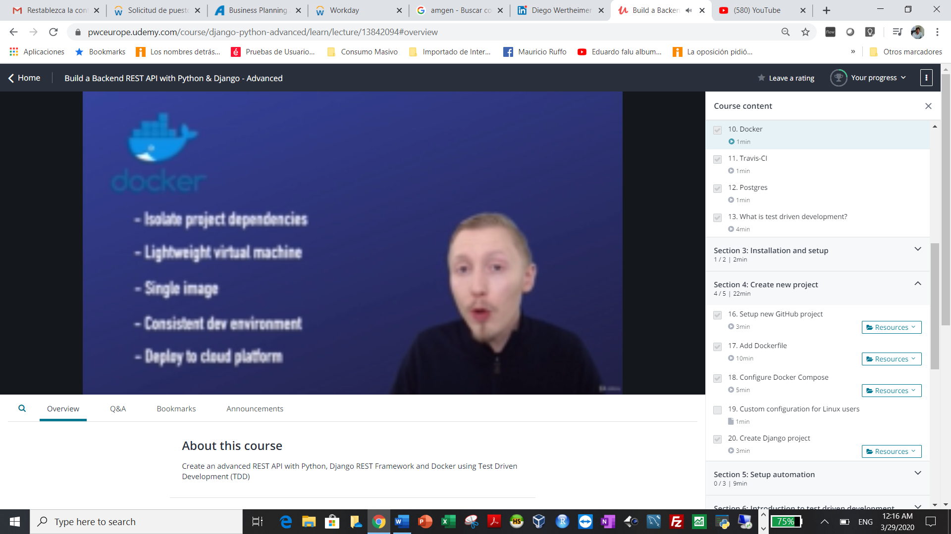

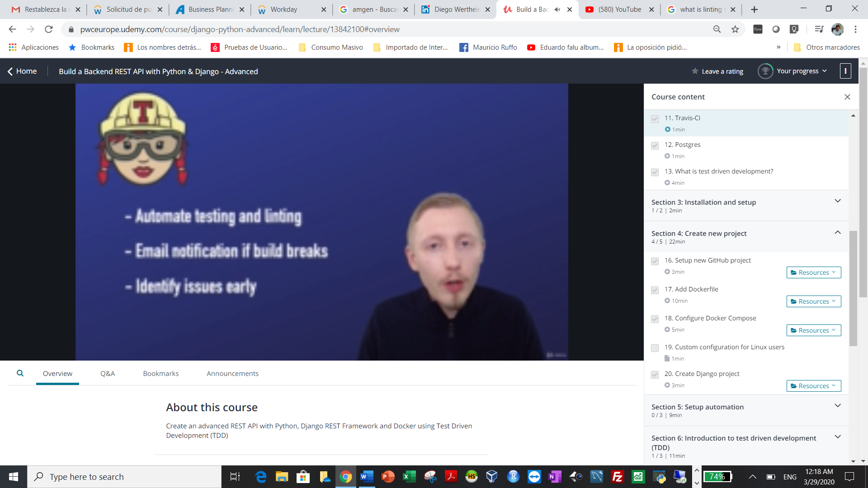

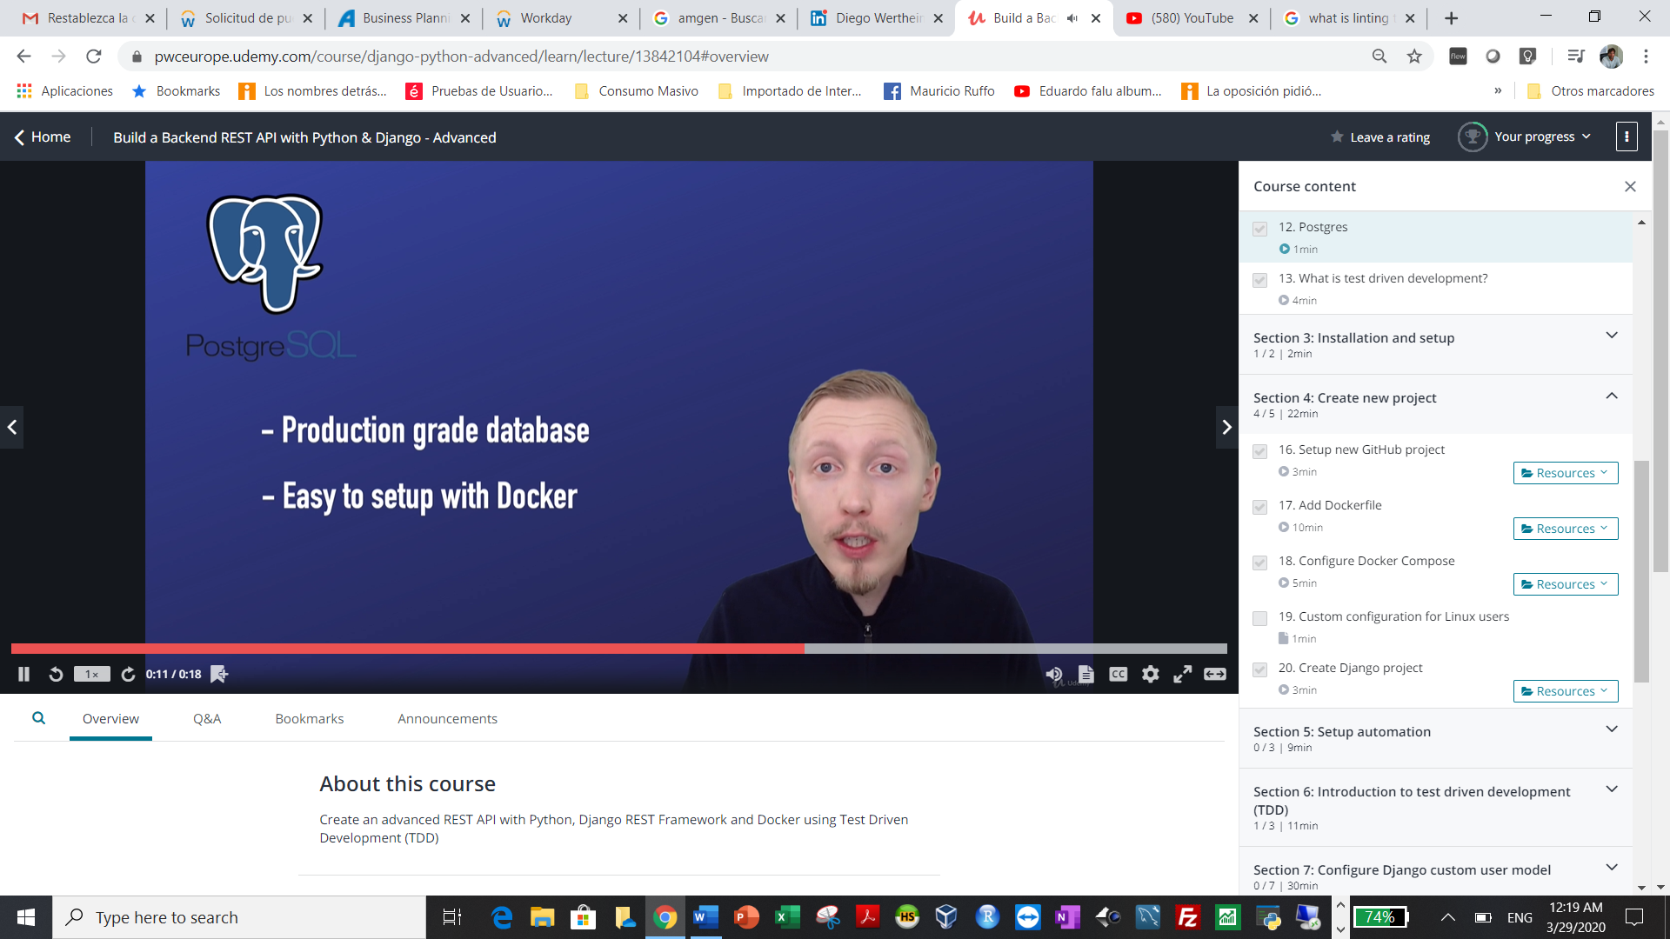

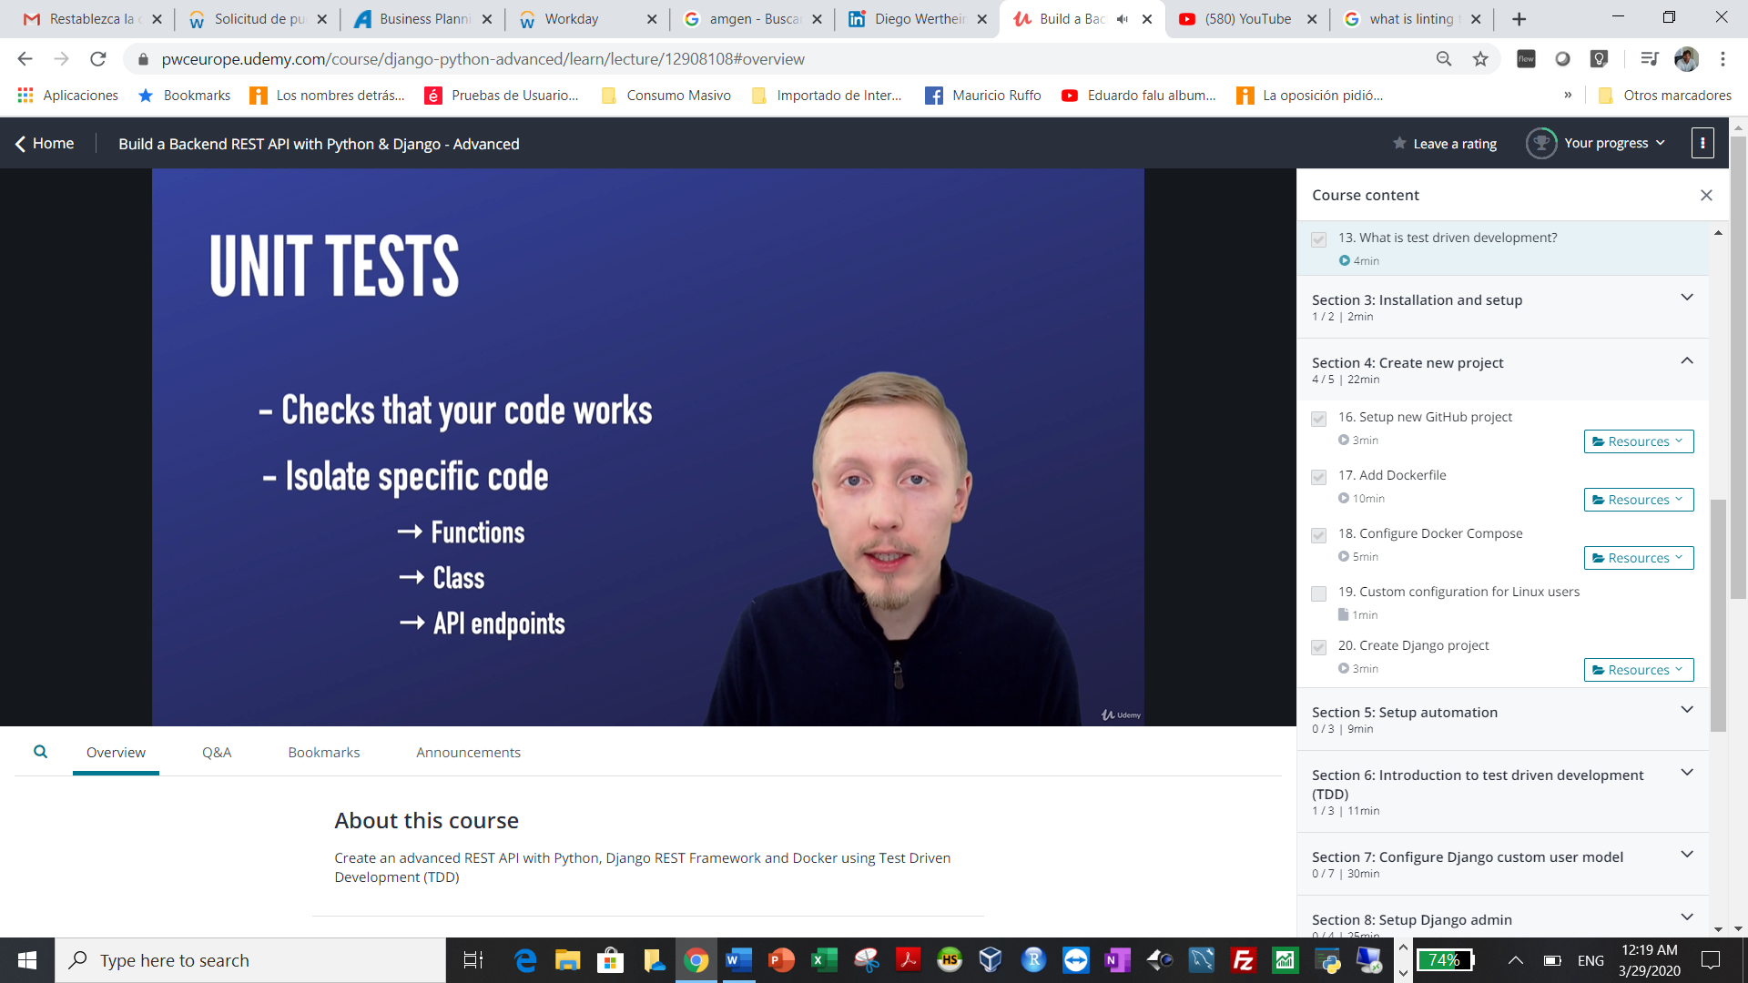

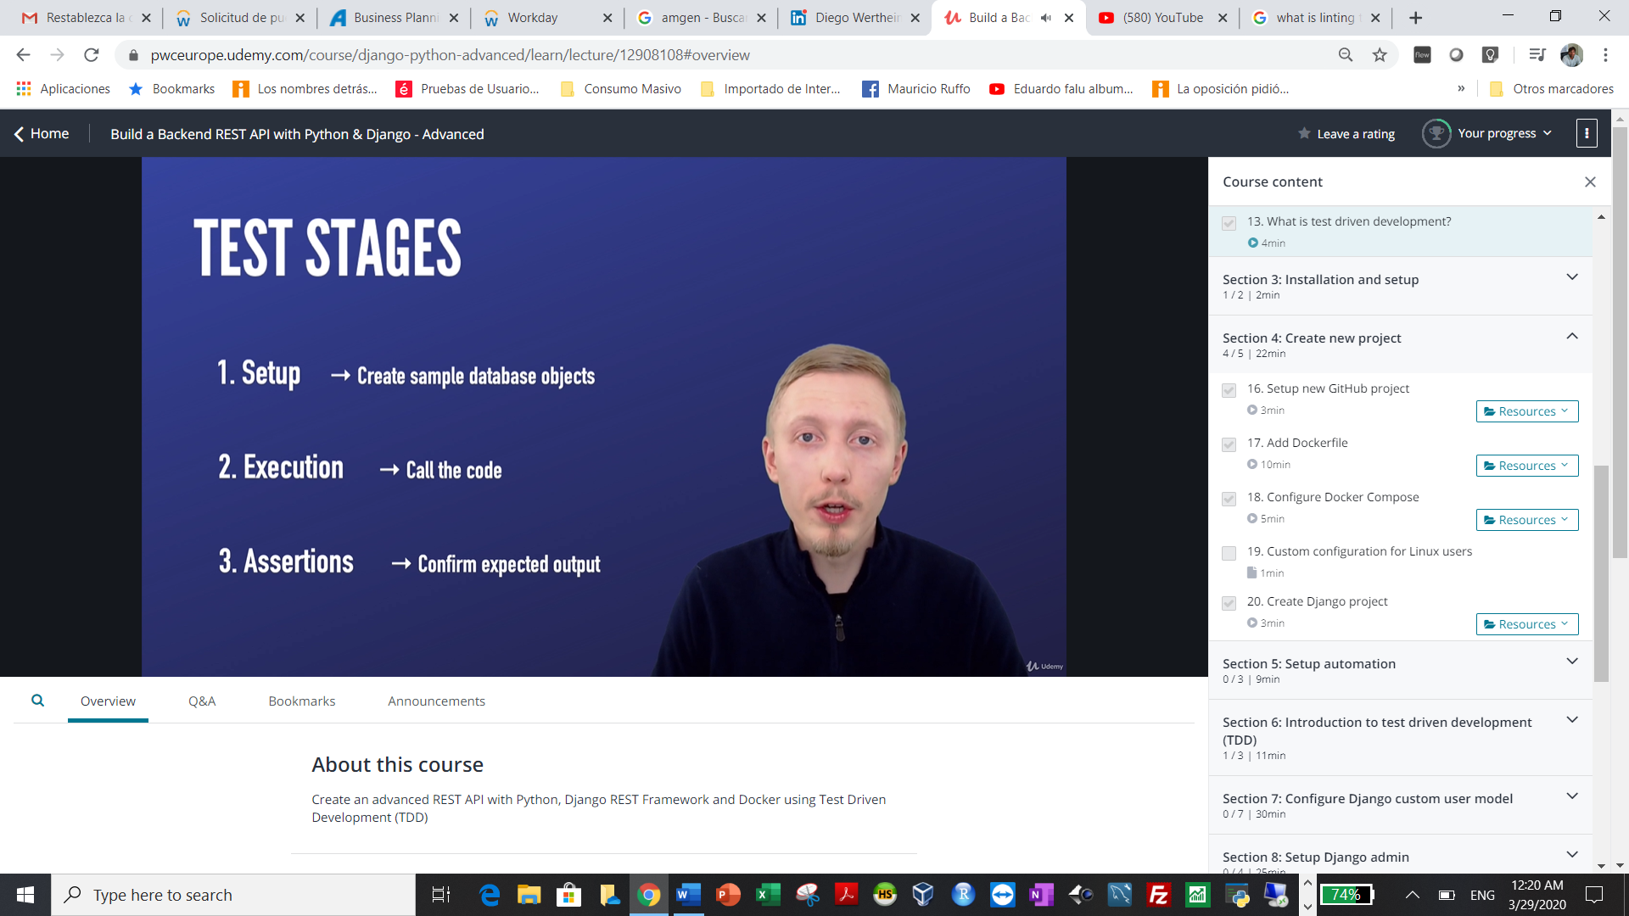

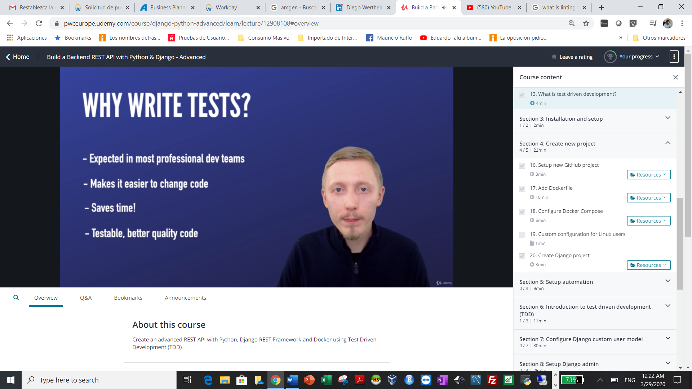

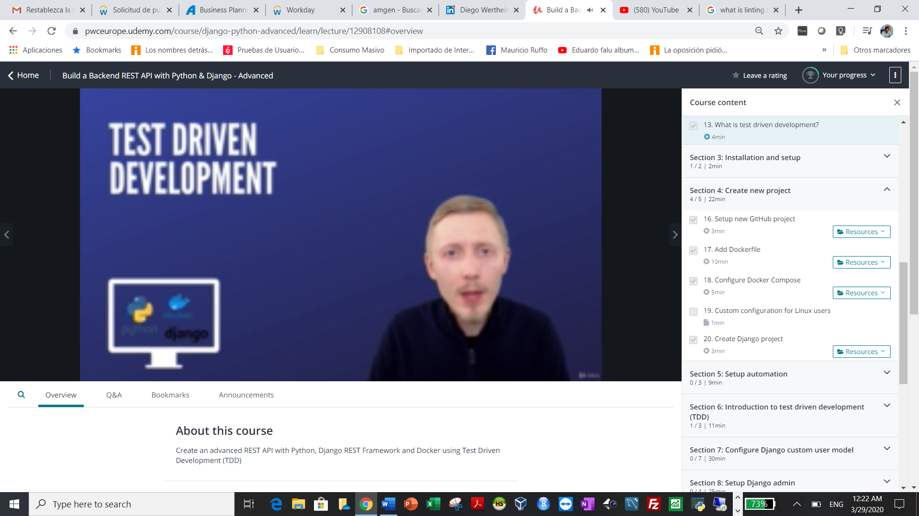

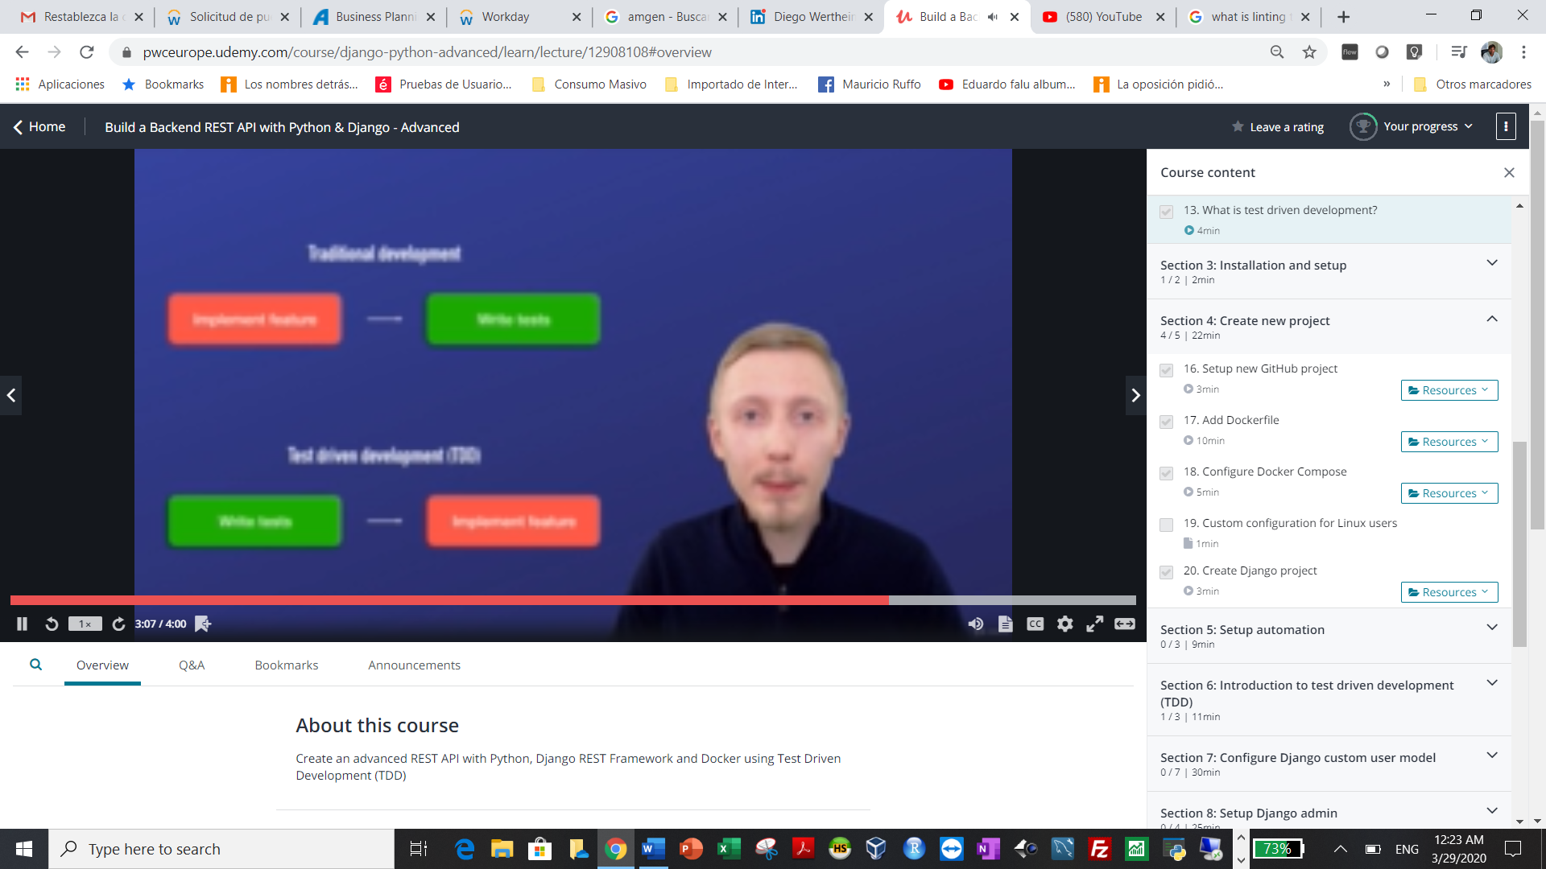

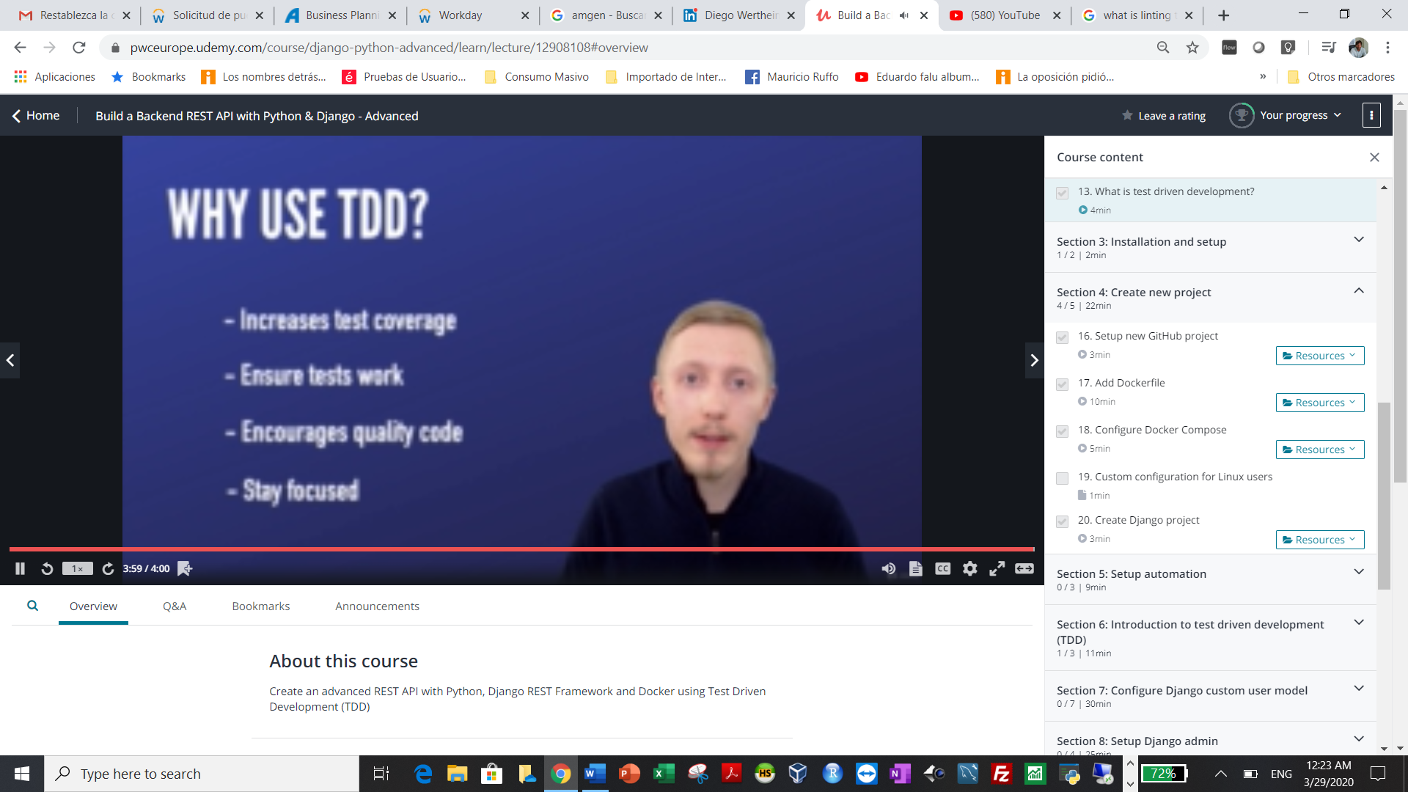

System setup

This course is designed to work on Linux, macOS and Windows (with Hyper-V enabled).

*Note: Docker will not run on Windows 10 Home. If you cannot upgrade to Windows 10 Pro I recommend following the course on*[*Ubuntu Desktop*](https://www.ubuntu.com/download/desktop)*running on*[*VirtualBox*](https://www.virtualbox.org/)*.*

Before continuing, ensure you have installed the following tools.

**Docker**

macOS and Windows users can install [Docker Desktop](https://www.docker.com/products/docker-desktop) which contains both Docker and Docker-Compose tools.

Linux users need to follow the instructions on [Get Docker CE for Ubuntu](https://docs.docker.com/install/linux/docker-ce/ubuntu/) and then [Install Docker Compose](https://docs.docker.com/compose/install/) separately.

You are good to go when you can successfully run:

docker-compose --version

**Atom Editor**

You may use whichever plain text editor you prefer, howerver this course uses [Atom](https://atom.io/).

**ModHeaders**

To test our API, we use [Google Chrome](https://www.google.com/chrome/) with the [ModHeader](https://chrome.google.com/webstore/detail/modheader/idgpnmonknjnojddfkpgkljpfnnfcklj?hl=en) extension.

**Git / GitHub**

During the course, we will be pushing the code to GitHub.

Ensure you have installed and configured [Git](https://git-scm.com/) and configured authentication to your [GitHub](https://github.com/).

See [Connecting to GitHub with SSH](https://help.github.com/articles/connecting-to-github-with-ssh/) for instructions on configuring authentication.

<https://help.github.com/en/github/authenticating-to-github/connecting-to-github-with-ssh>

